***Object Oriented Programming Experiment-10***

**Name:- Vamika Mahajan Sap Id:- 500096495**

**Batch: - B6 Branch: - B. TECH CSE CCVT**

**Ques1- Write a program for the following ArrayList (a) Read all elements from ArrayList by using Iterator, (b) Create a duplicate object of an ArrayList instance, (c) Reverse ArrayList content.**

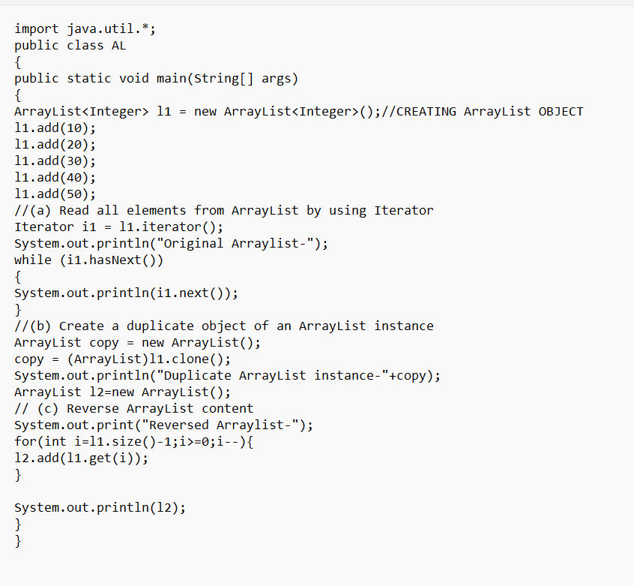

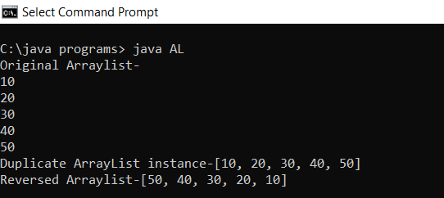

**Ques2- Write a program for the following HashMap (a) Find whether the specified key exists or not, (b) Find whether the specified value exists or not, (c) Get all keys from the given HashMap, (d) Get all key-value pair as Entry objects.**

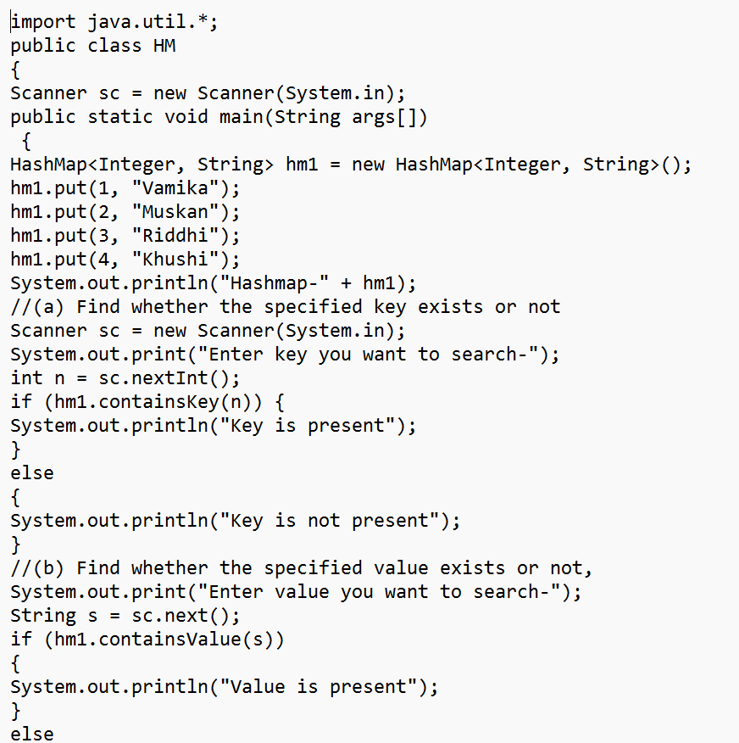

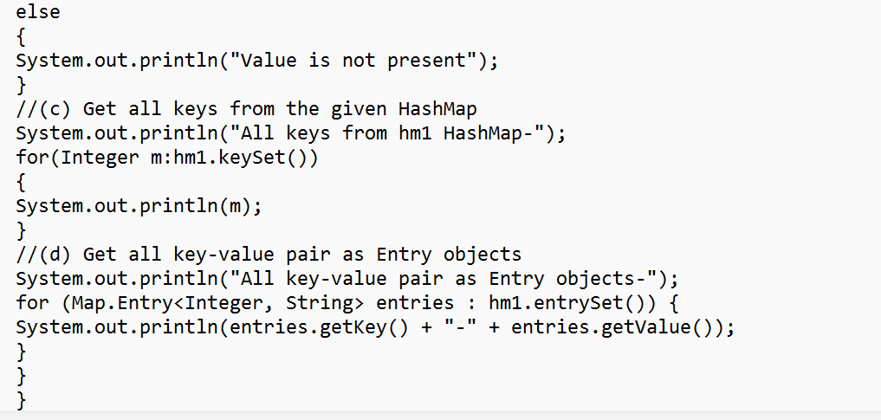

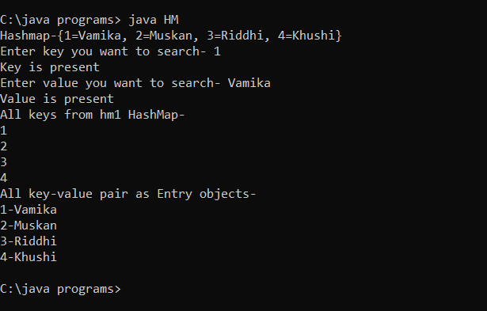

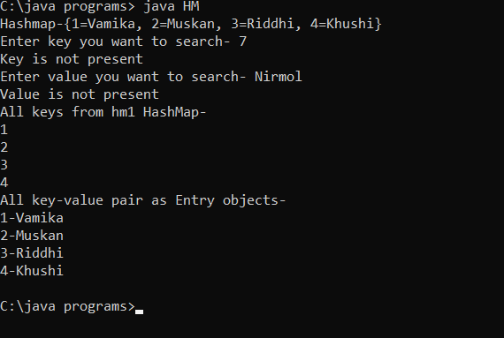

**Ques3- Write a program for the following HashSet (a) Copy another collection object to the HashSet object, (b) Delete all entries at one call from HashSet, (c) Search user-defined objects from HashSet.**

